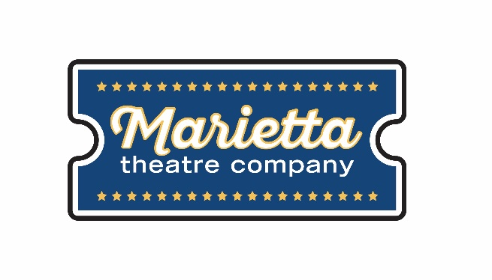

For more information:
Laurel Haislip
BRAVE Public Relations
404.233.3993
lhaislip@emailbrave.com
FOR IMMEDIATE RELEASE

Marietta Theatre Company’s You’re A Good Man, Charlie Brown to hit the stage April 12 – 27
The Peanuts are coming to downtown Marietta!

Marietta, Ga. (March 14, 2019) – Marietta Theatre Company welcomes audiences of all ages to the musical classic, You’re A Good Man, Charlie Brown, playing at the Lyric Studio on the Square from April 12-27! With book, music and lyrics by Clark Gesner, this Peanuts-inspired performance will delight theatergoers with all the well-loved, classic songs plus two new additions!

Based on Charles Schulz’s classic comic characters, You’re A Good Man, Charlie Brown follows Charlie as he decides to figure out how he can truly become a good person. With the help of all the beloved Peanuts characters, the audience follows Charlie Brown as he goes through experiences and tries to overcome them in his search towards becoming a better man. Adults and children alike will learn lessons along the way about decency and making the best out of the given circumstances.

You’re A Good Man, Charlie Brown is the fourth of five productions in Marietta Theatre Company’s second season. The remaining 2018-2019 production is Altar Boyz, which will play June 7-22, 2019.

You’re A Good Man, Charlie Brown will run at the Lyric Studio on the Square from April 12 – 27, Thursdays – Saturdays at 8 p.m. and Sundays at 3 p.m. Tickets start at $25 and are on sale now at https://mariettatheatre.tix.com. Individual tickets and VIP tables for the shows are also available for purchase.

“This family friendly show is a great way to bring to life the classic comic characters we all grew up loving,” said Gina-Ann Riggs, vice president and co-founder of Marietta Theatre Company. “We are thrilled to be putting on this musical that reminds all of us to make the best out of life and are sure our audiences will love it!”

For more information on Marietta Theatre Company and the 2018-2019 season, visit mariettatheatre.com or follow along on Facebook and Instagram using the hashtag #CharlieBrownMarietta.

About Marietta Theatre Company:
Marietta Theatre Company (MTC Players, Inc.) is a domestic 501(c)(3) with a mission to provide an atmosphere for the community to experience life together and introduce patrons to outstanding local talent all while supporting local charities. To stay updated on Marietta Theatre Company's latest news and performance schedule, join their email list by visiting www.mariettatheatre.com/join-our-email-list/.

###

